**A STUDY ON EEG AND EMG BASED PROSTHTIC HAND**

Saraswati Patil

Vishwakarma Institute of Technology, Pune, India.

[saraswati.jadhav@vit.edu](mailto:saraswati.jadhav@vit.edu)

**ABSTRACT**

Upper limb amputation is a condition that severely limits the activities of the amputees on a daily basis. Upper limb prothesis are designed and developed based on biopotential signal like Electromyograph (EMG) and Electroencephalogram (EEG). Myoelectric signal from remnant stub muscles is intended to smoothly restore the function such amputee limb. However, the collection of Biopotential Signals is tedious and challenging task. Additionally, once obtained, it typically needs a lot of processing resources to convert it into a user control signal. Various factors like electrode placement, each amputee has different range of motion, muscle contraction force and difference in limb posture. Therefore, prothesis system can customize itself to each individual amputee for optimal utility. This study discusses the different machine learning techniques to design electromyography pattern recognition based prothesis. These techniques significantly reduce the factors like contraction of muscle and movement of users. Multi-grasp prostheses are intended to help amputees carry out daily tasks more effectively. Different grasps like tip, lateral, tripod, cylindrical, spherical, and hook represent around 85% of those utilized in daily living activities. This paper discussed overall signal acquisition method for EMG and EEG signal and review of pattern recognition based myoelectric system for different grasp. A review of current challenges and suggestions for further research served as the conclusion of the paper.

**INTRODUCTION**

Amputation defines the loss of body part due to diseases or injury, most frequently referring to loss of limb. Various people worldwide are presently alive with amputation of the upper extremity. Prothesis replacement aims to restore the many functions of missing hand -a task which becomes progressively challenging with ascending level of limb loss. It is approximation that 1.6 million individuals with limb amputation were alive in the USA 2005, a number anticipated more than double by 2050.Upper limb amputation, making up for third of that number.

Cancer, Trauma and vascular disease are common causes of upper limb amputation. Major traumatic amputations occur far more commonly in men than in women. The amputation injuries are caused by motor vehicle trauma or industrial equipment mishaps. When a nation is actively engaged in war, traumatic amputation rates rise. Because of improvements in field medicine, the mortality rate after war-related injuries has been declining recently, leaving more survivors with grave wounds. This is thought to be one of the causes of the rising number of soldiers returning home after several amputations.[1]

In this paper, first part we discussed different types of Prothesis. Different types of components are used to design Prothesis. This paper also examined characteristics of successful Prothesis. Various points to take into account while selecting Prothesis. The second part of paper discussed Prothesis Hand based on patten recognition. The system consists of signal acquisition techniques, feature extraction, feature selection and pattern for different Hand motion. Pattern recognition systems are used to classify different grasp [2] of prothesis to perform daily activity of life.

There are seven distinct parts of amputation that can be constructed based on how the bones connect and function. The parts are shown in Fig. 1 and are known as forequarter, shoulder disarticulation, transhumeral, transradial, elbow disarticulation, wrist disarticulation and transcarpal. Upper extremity prostheses classified as prosthetic arm and terminal device, prosthetic shoulder, prosthetic elbow, prosthetic wrist. Fig. 1 shows the categories of Upper Limb Amputation.[3].

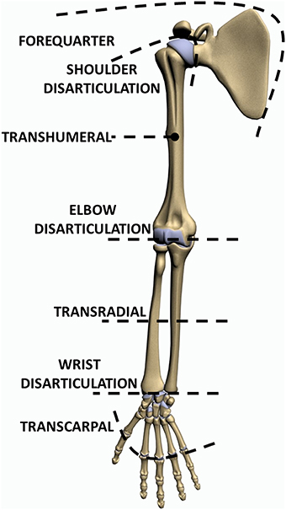

**Fig. 1** Types of Upper Limb Amputation

Prothesis are classified into three main courses: active, passive and hybrid prothesis devices.[4]

**Passive Prothesis:**

The passive prosthesis is used when comfort and aesthetics are the top priorities. Fig. 2. represent key components of passive prothesis device. It is clear that the appearance is realistic. PPD are affordable and have a cosmetic appearance that is attractive to the eye. Despite their practical limitations, users continue to prefer passive devices. PPD's usefulness is restricted to simple tasks like pushing, pulling, and carrying objects. A passive prosthesis is used in some capacity as approximately one in three amputees.

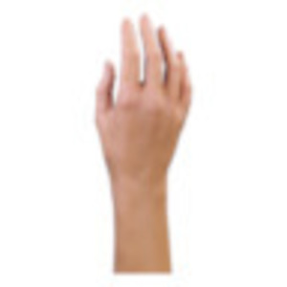

**Fig.2** Cosmetic Glove for Women[5]

**Active Prothesis:**

The ability to generate power is the primary difference between active and passive prosthetic systems. Myoelectric and body-powered active prosthesis are two categories of prosthetic arm. Body Powered Prothesis consist of components like Harness, Control cable, Socket, Wrist and Terminal Device as shown in Fig.3

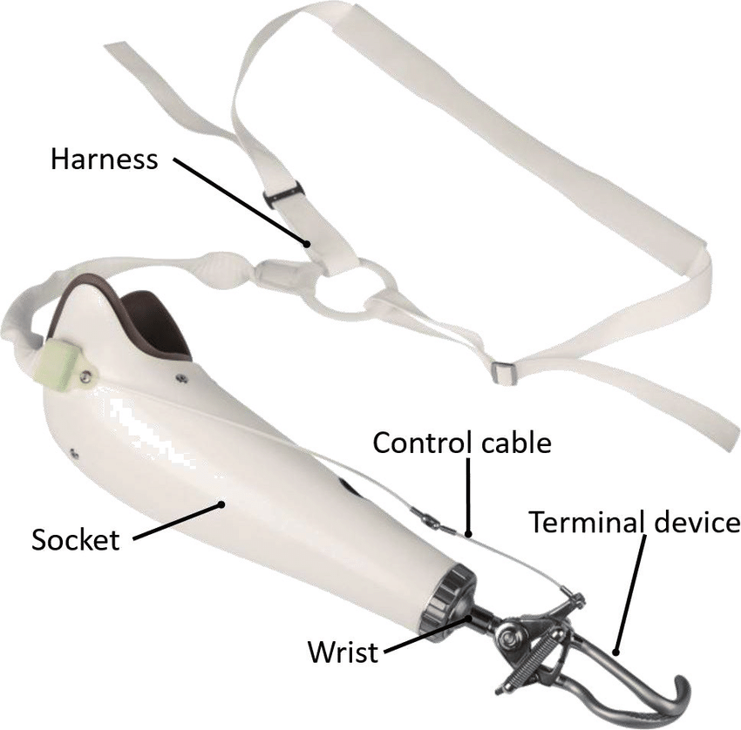

**Fig.3** Body Powered Device [6]

The power source for myoelectric upper extremity prosthesis is of electric motors that are powered by an outside source. The muscle activation from the remaining limb controls the joint moves. Surface electrodes detect electromyographic (EMG) impulses from the limb remnant.[7] EMG signals are then amplified to increase the strength of signal .Further ,EMG signal processed by a controller to power battery-operated motors that control the wrist, hand or elbow.90 % patients are used myoelectric prothesis as primary device. It is standard in Western Country for upper limb amputee. The main benefit of myoelectric prothesis that muscles are operate close and open the hand similar to natural hand.**Fig.4** shows myoelectric prothesis arm.

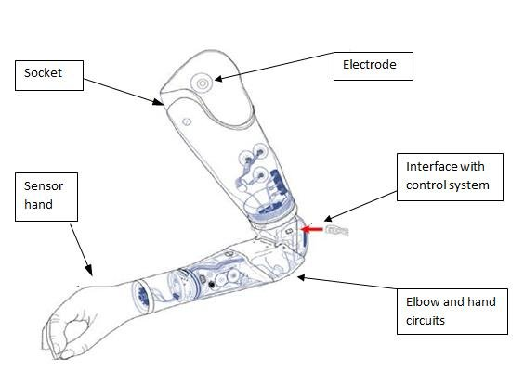

**Fig.4** Myoelectric prothesis arm [8]

**Hybrid Prothesis:**

A hybrid prosthetic is less frequently utilized than other prosthetic devices. A hybrid prosthetic device combines myoelectric and body powered prothesis to construct a practical device. Hybrid prothesis combines the yields from the different prothesis.

**Characteristics of effective prothesis:**

* Pleasant to wear
* Simple to put on and take off
* Robust
* Lightweight
* Cosmetically attractive
* It must function fit mechanically
* only necessitate reasonable care
* Its usage mainly depends on the motivation of the individuals [9]

**Points to take into account while selecting a prosthesis**

* Level of Amputation level: below the Shoulder and Elbow
* Outline of the residual limb- Fitting
* Intended prosthetic function: chemical, electrical
* Cerebral function of the patient
* The patient's line of work (e.g., desk job vs manual labor)
* Interests outside of work for the patient (i.e., hobbies)
* The prosthesis's importance for appearance
* Financial incomes of the patients. [9]

**Methods**

Prothesis Hand system based on biopotential signal techniques like electroencephalogram (EEG) and electromyogram (EMG). Biopotential signal generation is based on action potential.

**Action Potential:**

The operation of nervous system depends on neurons system function. Fig.5 shows Neurons can communicate with one other via electrical events called ‘Action Potentials’ and chemicals called ‘Neurotransmitter’. The cell membrane (the boundary between cell inside and outside) has many channels that allow positive and negative ions to enter and exit the cell. [10] The dendrite receives signals from other neurons through axon terminals by release of neurotransmitter. These neurotransmitters function as chemical signals when they link to dendrite receptors. It crosses space (one million of an inch) called synapse. By allowing charged ions to enter and exit the cell, the binding opens ion channels, transforming chemical signals into electrical signals. Ion channels that bind together allow charged ions to enter and exit cells, transforming chemical signals into electrical signals. A single neuron can have a huge number of dendrites receiving input; nonetheless, Action Potential is only set off if the combined action of many dendrites causes the overall change charge to change enough. Typical value of an Action Potential is -55mv. The signal is further relayed when an Action Potential rushes down the axon and causes neurotransmitter release at the opposite end.

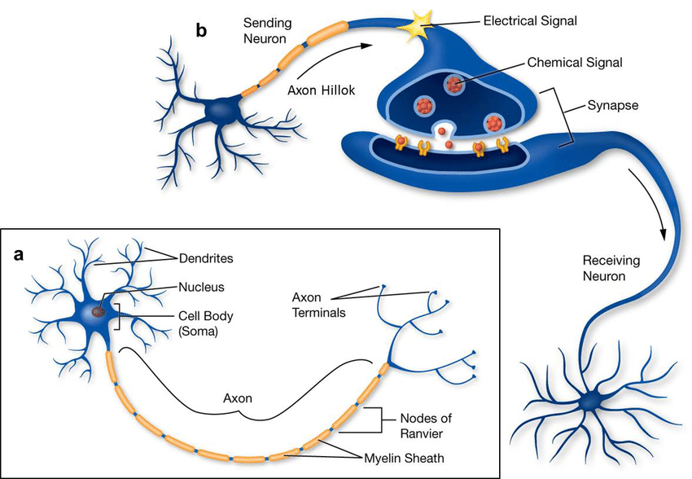

**Fig. 5 Neuron Communication [11]**

**Electroencephalogram (EEG) :**

There are billions of cells in the brain, half of which are neurons and the other half of which support and enable the activity of neurons. Membrane transport proteins that pump ions across their membrane provide neurons an electrical charge. Via synapses, which serve as entry points for inhibitory or excitatory activity, these neurons are strongly connected to one another.

A postsynaptic potential is a small electrical impulse produced by any synaptic action. A modest electrical impulse known as a postsynaptic potential is produced by any synaptic activation. Without direct contact, it is challenging to accurately identify the burst of a single neuron. But, when a large number of neurons fire simultaneously, an electrical field is created that is powerful enough to go through bone, tissue, and the skull. Electrons can be pushed or pulled onto the metal of the electrodes when the wave of ions reaches the electrodes on the scalp. Voltage across time is used to measure the push or pull difference. It can be measured on the head surface.[12] Fig.6 shows generation of EEG Signal.

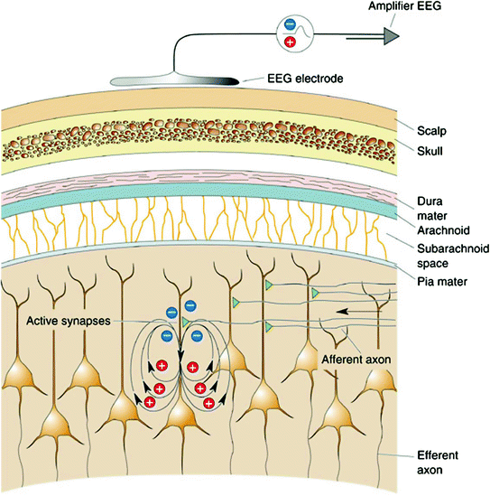

**Fig. 6** Generation of EEG Signal [12]

**EEG Signal Recording:**

American clinical neurophysiology Society guidelines from 2016 recommended to use 21 electrodes to use 10-20 system for electrode placement. The EEG signal society guidelines consist usage of minimum 21 electrodes placement on scalp, at least 3 montages and selection of 16 or more channels. **Fig**. 7 shows 10-20 system EEG signal recording system. EEG waves are subdivided into different types of waves like Gamma, Beta, Alpha, Theta and Delta. Table 1. shows characteristics of EEG Signal.

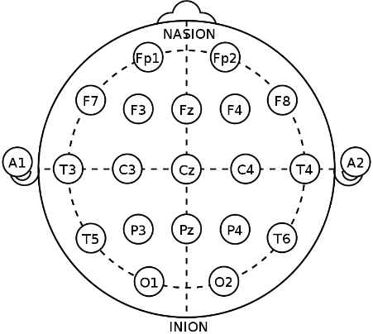

**Fig. 7** 10-20 System EEG electrode Placement [12]

|  |  |  |  |  |  |
| --- | --- | --- | --- | --- | --- |
| **SR. No** | **EEG Wave** | **Frequency** | **Amplitude** | **Lobes of Brain** | **State** |
| 1. | Delta (δ) | 0.5 to < 4 Hz | 20-200 μv | Frontal Cortex | deep, dreamless sleep, Unconscious state of lack of oxygen |
| 2 | Theta (θ) | 4 to <8 Hz | 100-150 μv | Parietal and Temporal Lobe | Relaxation state |
| 3 | Alpha (α) | 8 to <13 Hz | 20-100 μv | Occipital lobe and  Parietal lobe | Awake State. |
| 4 | Beta (β) | 13 to 30 Hz | 5 -20 μv | Frontal lobe | Focus and active Mindset |
| 5 | Gamma (γ ) | >30 Hz | < 2 μv | Different Sensory and Non-Sensory  Cortical Networks | Brain Cognitive functions and task at a high level like information processing. |

**Table 1.** Characteristics of EEG Signal

**Electromyography (EMG) Signal:**

The **Electromyography (EMG)** technology is a way to measure and capture the electrical activity that muscles produce. Actually, the word "myo" means muscle.The human brain generates commands through neurons when muscle contractions and relaxation take place, making it possible for the human skeletal system to move in a variety of ways. These kinds of commands travel through the neural system and cause the muscles to contract electrically. Electromyography is the recording of the electrical potential that a muscle has been generating.

Skeletal muscles are excited by stimulation through nerve fibres. The axonal process of nerve fibre forms a junction with a skeletal muscle’s membrane known as neuromuscular junction. The nerve cells which form the junctions are known as motor neurons as shown in **Fig.** 8. One motor neuron and all the muscle fibres it innervates make up a single motor unit.

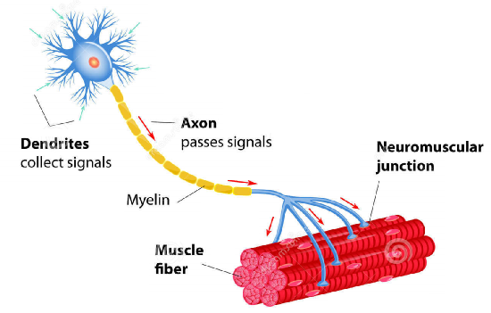

**Fig.8** Motor Unit [14]

The brainstem or spinal cord is where motor neurons' cell bodies are found. These neurons' large-diameter, myelinated axons enable them to propagate action potential at high velocities. Motor-end-plate refers to the part of the muscle membrane that is immediately beneath the terminal segment of the axon. All of the fibres innervated by an alpha (lower) motor neuron are simultaneously triggered and contract once this neuron produces an action potential. A single muscle's contractions are frequently coordinated by groups of motor units. A motor pool is the collective name for all of the motor units that make up a muscle. A Motor Unit Action Potential is created when the motor unit is turned on. As long as muscles are needed to produce force, the activity is continually repeated.

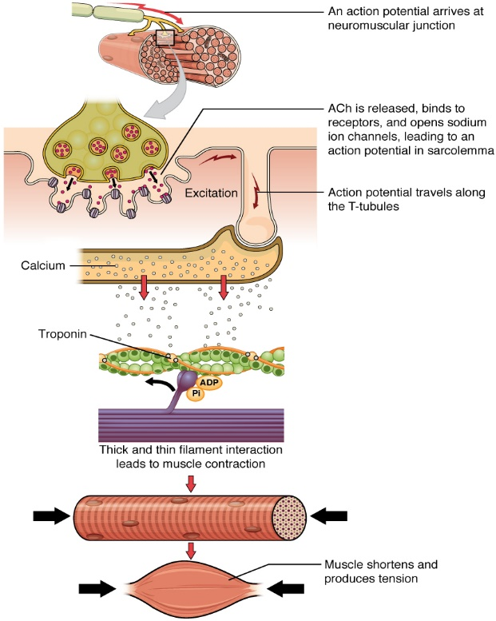

**Fig.9**  Muscle Excitation and Contraction [15]

**EMG Signal Recording:**

EMG electrodes are used to measure the bioelectric activity that occurs within human muscle. EMG electrodes come in two different categories as skin (surface electrodes) and Inserted electrodes. Inserted electrodes subdivided into two categories as needle electrode and fine wire electrode.

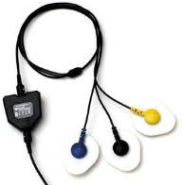.

**Fig.10** Surface Electrode [16]

**Properties of EMG signal:**

Raw EMG (without any processing) range is 0.1 microvolt to 20 mv. EMG signal frequency varies from 2Hz to 2KHz. The noise-free EMG baseline is visible after the muscle has relaxed. The baseline noise average must be less than 3-5 microvolts.[17]

**Experiment:**

This paper reviewed bipotential pattern recognition based prothesis hand system in detail as shown in Fig. 11.

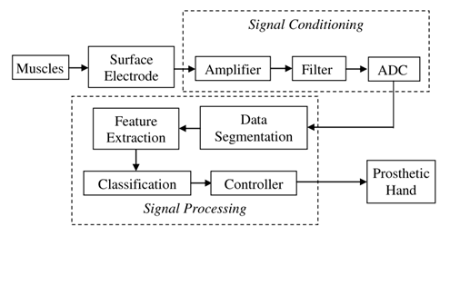

**Fig.**11 Prothesis hand control system [18]

People who have had limbs amputated can regain functionality with the use of a prosthesis based on an electromyogram (EMG). Many enthusiastic biomedical researchers in poor nations are particularly interested in creating an artificial hand and pattern identification of EMG signals for hand actuation. While some groups working on surface EMG-based pattern recognition have concentrated on creating algorithms to increase classification accuracy, other teams have worked on creating mechanical structures and enhancing the actuation system for prosthetic hands with many degrees of freedom.

In rehabilitation engineering, features from steady state and dynamic EMG signals can be decoded into time domain, frequency domain, time-frequency domain, and time scale domain information about the goal. EMG signals identifying the hidden data to operate assistive equipment such as orthotics, prosthetics, etc.

**EMG Pattern recognition System:**

Many domains of biomedical engineering, including myoelectric control, have achieved success with pattern recognition systems. [19]. As depicted in Fig. 12, it typically includes phases for data pre-processing, segmentation, feature extraction a, dimensionality reduction and classification.

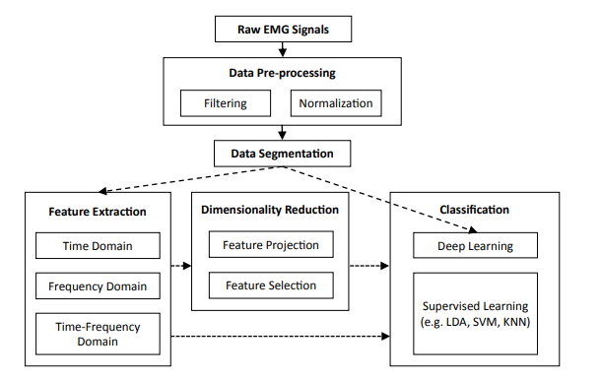

**Fig.**12 Structure of EMG Pattern Recognition System [19]

Different hand motion like hand close , hand open , wrist flexion , wrist extension , ulnar deviation /hand supination, and radial deviation are recorded using EMG signals. Patterns of EMG signals are used to control the motions of prothesis Hand.

**Conclusion:**

This paper discussed different types of prothesis devices and characteristics of successful prothesis device. This study examined EEG and EMG pattern recognition based prothesis system. Action potential, EEG signal generator, EEG signal recording, EMG signal generation, EMG Signal recording and characteristics of EEG and EMG signal studied in detail. This paper also reviewed Prothesis Hand system control for different Hand Motion like hand open (HO), hand close (HC) etc.

**References:**

1. O. C. Aszmann and D. Farina, “Bionic Limb Reconstruction.”
2. Furui, A., Eto, S., Nakagaki, K., Shimada, K., Nakamura, G., Masuda, A., … Tsuji, T. (2019). A myoelectric prosthetic hand with muscle synergy–based motion determination and impedance model–based biomimetic control. Science Robotics, 4(31), eaaw6339. doi:10.1126/scirobotics. aaw6339
3. Cordella, F., Ciancio, A. L., Sacchetti, R., Davalli, A., Cutti, A. G., Guglielmelli, E., & Zollo, L. (2016). Literature Review on Needs of Upper Limb Prosthesis Users. Frontiers in Neuroscience, 10. doi:10.3389/fnins.2016.00209
4. Brack, R., & Amalu, E. H. (2021). A review of technology, materials and R&D challenges of upper limb prosthesis for improved user suitability. Journal of Orthopaedics, 23, 88–96. doi:10.1016/j.jor.2020.12.009
5. Ottobockus.com. Passive Arm Prostheses. [online] Available at: https://www.ottoboc kus.com/prosthetics/upper-limb-prosthetics/solution-overview/passive-ar m-prostheses/; 2019. Accessed March 9, 2020.
6. Y. Dabiri, S. Najarian, M. R. Eslami, S. Zahedi, H. Farahpour and R. Moradihaghighat, "Comparison of passive and active prosthetic knee joint kinematics during swing phase of gait," 2010 17th Iranian Conference of Biomedical Engineering (ICBME), Isfahan, Iran, 2010, pp. 1-3, doi: 10.1109/ICBME.2010.5704998
7. ota A. Materials of Prosthetic Limbs. Pomona: California State Polytechnic University; 2017, 2010. Myoelectric Prosthetic Components for The Upper Limb. [ebook] North Carolina: BlueCross BlueShield of North Carolina, pp.1–2. Available at: https://www.bluecrossnc.com/sites/default/files/document/attachment/service s/public/pdfs/medicalpolicy/myoelectric_prosthetic_components_for_the_upper_li mb_6.pdf.
8. X. X. Liu, G. H. Chai, H. E. Qu and N. Lan, "A sensory feedback system for prosthetic hand based on evoked tactile sensation," 2015 37th Annual International Conference of the IEEE Engineering in Medicine and Biology Society (EMBC), Milan, Italy, 2015, pp. 2493-2496, doi: 10.1109/EMBC.2015.7318898.
9. Bosman CE, van der Sluis CK, Geertzen JHB, Kerver N, Vrieling AH (2023) User-relevant factors influencing the prosthesis use of persons with a transfemoral amputation or kneedisarticulation: A meta-synthesis of qualitative literature and focus group results. PLoS ONE 18(1): e0276874. https://doi.org/10.1371/journal. pone.0276874
10. Fry, C. H., & Jabr, R. I. (2010). The action potential and nervous conduction. Surgery (Oxford), 28(2), 49–54. doi:10.1016/j.mpsur.2009.12.001
11. <https://learn-genetics.b-cdn.net/neuroscience/neurons/neurons-2.jpg>
12. Siuly, S., Li, Y., & Zhang, Y. (2016). Electroencephalogram (EEG) and Its Background. EEG Signal Analysis and Classification, 3–21. doi:10.1007/978-3-319-47653-7_1
13. Houssein, Essam H., Asmaa Hammad, and Abdelmgeid A. Ali. "Human emotion recognition from EEG-based brain–computer interface using machine learning: a comprehensive review." Neural Computing and Applications (2022): 1-31
14. <https://kajabi-storefronts-production.kajabi-cdn.com/kajabi-storefronts-production/blogs/2147489269/images/9WD4uuj6RVuUd2nb5RoF_Concentric_Shortening_17_1_.png>
15. <https://med.libretexts.org/@api/deki/files/629/1010a_Contraction_new.jpg?revision=1>
16. Webster, John G. Encyclopedia of medical devices and instrumentation. John Wiley & Sons, Inc., 1990.
17. Arul. “A Review on Noises in EMG Signal and its Removal.” (2017).
18. Purushothaman, G., & Ray, K. K. (2014). EMG based man–machine interaction—A pattern recognition research platform. Robotics and Autonomous Systems, 62(6), 864- 870. doi:10.1016/j.robot.2014.01.008
19. Ganesh Naik. “Biomedical Signal Processing Advances in Theory, Algorithms and Applications “, Springer.